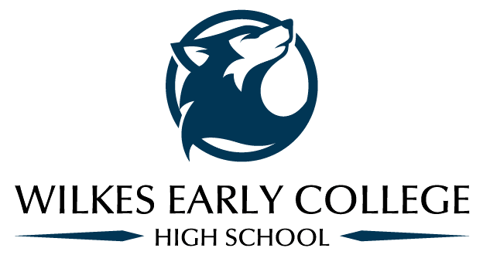
Mr. Matthews Class
Email: matthewsc@wilkes.k12.nc.us

World History
The World History course will address six (6) periods in the study of World History, with a key focus of study from the mid 15th century to present. The standards of this course are grouped in a way that reflects accepted periodization by historians. The learning standards of this course have been written to focus around a basic core of chronologically-organized periods and events in history in order to have a set of learning standards that can be reasonably taught and learned with some depth and not just memorization of facts, within the time available for classroom instruction.
Schedule: (Please realize that this is a tentative schedule and may change due to students needs.)
Unit One-Historical Thinking August 17-August 25
Unit Two-Ancient Civilizations August 26-September 11
Unit Three-Dark Ages/Medieval September 14-September 25
Unit Four-Renaissance & Reformation September 28-October 9 Unit Five-Exploration & Expansion October 12-October 26
Unit Six-Revolutions October 27-November 13
Unit Seven-Global Conflict November 16-December 2
Unit Eight-Globalization December 3-December 16

Materials Needed
A Composition Book (this will become the student’s Current Event Journal)
A 3-Ring Binder or 3-Subject Notebook with College-Rule paper
Pencils and Pens
A USB Drive
Note: Please bring these materials with you to class daily.

Grading
The following is how the student’s grade will be broken down. They will be graded on a total point system where every separate assignment will have a point value that will count into their total overall grade. This allows for every student to flourish and not just those who are excellent test takers or those who are excellent in their classwork or homework. If there are questions please feel free email me.

Scale: A = 100-90
B = 89-80
C = 79-70
D = 69-60
F = 59-0

